

**Lab No 7 Artificial Intelligence**

Name ALi hassan

ID BIT-23F-017

Class Artificial Intelligence

Data 8/12/24

Class Teacher Miss Aqsa Umar

**Task1.**

Write a Python function that draws a square using asterisks (*). The side length of the square should be provided by the user.Code:

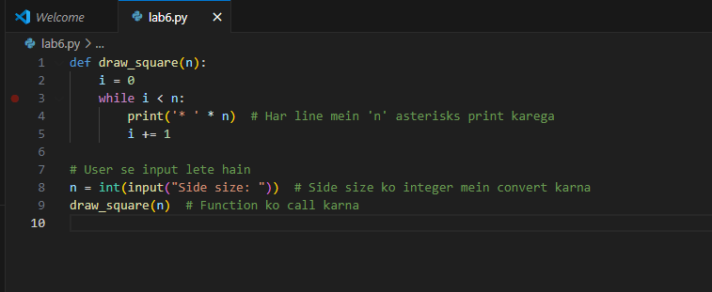

**Output:**

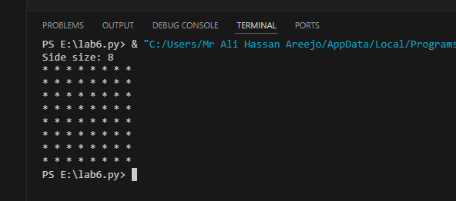

**Task 2.**

Write a Python function that takes a list of numbers as input and returns the sum of only the even numbers.

**Code:**

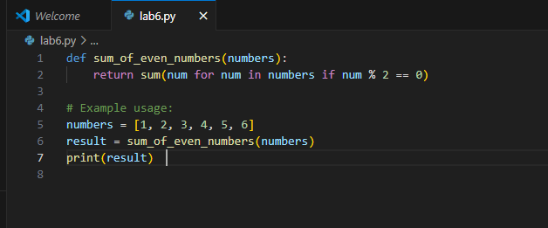

**Output:**

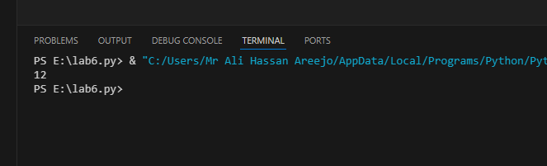

**Task 3.**

Write a Python function that takes a number as input and counts down to zero, printing each number.

**Code:**

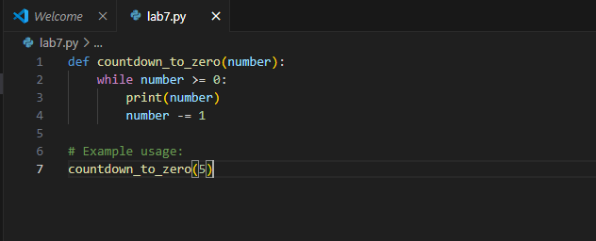

**Output:**

